Inhalation toxicity of cinnamaldehyde:

A physiologically based kinetic modeling approach to study route-to-route extrapolation

BSc. J.J. van der Lugta,1,[1], Dr. N.I. Kramerb,2, Dr. Ir. M.T.O. Jonker c,1

a MSc student in Toxicology and Environmental Health

b Daily supervisor

c Thesis examiner

1 Institute of Risk Assessment Sciences, Utrecht University, PO Box 80125, 3508 TC Utrecht , The Netherlands

1 Toxicology Chair Group, Wageningen University, PO Box 8000, 6700 EA Wageningen, The Netherlands

Abstract

Using physiologically based kinetic (PBK) modelling novel, chemical exposure scenarios can be modelled and analysed to form an understanding of the toxicokinetics and possible adverse health effects without having to perform in vivo experiments. In this study, an oral exposure PBK model in rats and humans of cinnamaldehyde (CNMA) was adapted to also model CNMA toxicokinetics after inhalation. The model parameters where derived based on *in vivo* rat exposure data and *in silico* calculated coefficients. The model was then used to predict CNMA tissue concentrations in both rats and humans. CNMA is a reactive aldehyde that is used as a flavouring agent in different food products. More recently CNMA has been adopted as a flavouring agent for electronic cigarettes, i.e., vaping devices. CNMA is a Generally Regarded as Safe (GRAS) flavouring agent. Unfortunately inhalation exposure is not considered for flavouring agents. Worryingly, recent research has linked CNMA to adverse health effects such as oxidative stress en immune suppression in the lungs when inhaled. Simulation results for the human inhalation model show that predicted CNMA concentration are in the range at which immunosuppressive, mitochondrial dysregulation and/or cytotoxicity effects are noted in *in vitro* models using human and mice cells including epithelial, fibroblast and embryonic stem cells. Furthermore, model simulation indicate that CNMA concentration are over 250 times higher in the lung when inhaled compared to oral exposure. The ability to predict tissue concentrations in novel exposure scenarios based on population metrics represents a key feature of PBK modelling which can be used on both novel and known chemicals.

*Keywords:* Inhalation, Physiologically based kinetic modelling, Population, Flavouring, Electronic cigarette

1. Introduction

A decline in cigarette use has been noted by the WHO in almost all regions across the planet (WHO., 2021). This can be ascribed to a number of factors such as increased public awareness of the adverse health effects of smoking cigarettes, the introduction of nicotine patches and by the rise of electronic cigarettes (Hartmann-Boyce et al., 2021). With an electronic cigarette a consumer is no longer exposed to the burning of tabaco and thus to the associated harmful chemicals. Electronic cigarettes work by the vaporization and inhalation of a blend of nicotine, propylene glycol and/or glycerol. Furthermore, electronic cigarette mixtures are often enhanced with the addition of flavouring agents (Omaiye et al., 2019; Page & Goniewicz, 2021). Examples of such flavouring agents are vanillin (vanilla), benzaldehyde (almond) and cinnamaldehyde (cinnamon). A considerable part of the appeal of electronic cigarettes is the absence of a host of toxic and carcinogenic compounds normally found in cigarette smoke. Yet, a mounting body of evidence suggest adverse health effects can be seen after use of electronic cigarettes (Chatham-Stephens et al., 2014; Effah et al., 2022; Hua & Talbot, 2016). The exact cause of these adverse health effects is as of yet unknown.

The reactive aldehyde cinnamaldehyde (CNMA) is an interesting possible candidate that might contribute to adverse health effects. Aldehydes are compounds which possess a carbonyl group with a substituent Hydrogen atom (Lopachin & Gavin, 2014). These carbonyl groups are known for the electrophilic characteristics and associated reactivity. An assortment of aldehydes is associated with adverse health outcomes. These include the known cancer causing agents: Formaldehyde, Acrolein and Crotonaldehyde ( IARC Working Group on the Evaluation of Carcinogenic Risks to Humans., 2021). CNMA is present in multiple vape products at concentrations up to 343 mg/ml with possible high retention after exposure (Khachatoorian et al., 2022; Omaiye et al., 2019). CNMA is noted to induce toxicity in in vitro systems including oxidative stress, inflammatory responses and reductions in cell viability (Behar et al., 2014; Bhattacharya et al., 2021; Clapp et al., 2017, 2019; Gerloff et al., 2017; Ka et al., 2003; Muthumalage et al., 2018)

Flavouring agents are regulated in the United States by the Food Additives Amendments to the U.S. Federal Food, Drug, and Cosmetic Act. In Europe they are considered flavouring agents and regulated by de European Food Safety Authority Flavouring and Food Additive panel. Flavouring agents that occur naturally such as CNMA have historically received very little attention as either no adverse effects have been noted in food where it is present naturally or the concentrations used are very low. CNMA is Generally regarded As Safe (GRAS) in both Europe and the United States and therefore allowed respectively either as an flavouring agent or and food additive. Unfortunately, this approach neglects to consider inhalation exposure (Dinu et al., 2020). An infamous example of a flavouring agents that has been noted to cause adverse health effects when inhaled is Diacetyl (Athleen et al., 2002; Hubbs et al., 2008; Morgan et al., 2008) .

Unfortunately no inhalation exposure data is available for CNMA. In cases such as CNMA where no experimental data for the inhalation route is available ECHA recommends using route to route extrapolation with additional testing using PBK modelling (ECHA, 2012). PBK modelling involves mathematically solving the movement of chemicals through the different organs using the blood. This mathematical model is based on physiological parameters such as blood flow and organ weights, chemical specific parameters such as lipophilicity, partition coefficients and metabolic rates. The aim of PBK modelling is to be able to predict the concentration of the target chemical at a specific target site. A PBK modelling approach has multiple advantages in this case. Reduced reliance on ethically troubled animal testing methodologies by employing route-to-route extrapolation based on previously gathered *in vivo* data without the need for additional animal testing. With an interesting exposure route comparison model for styrene being published recently (Kabadi et al., 2019). The possibility to employ population based modelling. Population based modelling can reveal sensitive populations otherwise unaccounted for using a “standard” human with a recent examples using population model (Kasteel et al., 2021). And the opportunity to rapidly adapt effective modelling approaches to similar relevant compounds.

For CNMA an PBK model has been developed for oral exposure. The model in question was used to estimate the DNA adduct formation in the liver of rats and humans (Kiwamoto et al., 2016). This model will be used as basis for the creation of inhalation models for both human and rat. This will be done to validate the inhalation approach. When the inhalation model is validated the human model will be adopted into a population model. These models will then be used to assess if exposure to CNMA in a simulated electronic cigarette scenario is predicted to results exposures that could lead to possible adverse effects.

# Abbreviations

PBK Physiologically base kinetic modelling

CNMA Cinnamaldehyde

GRAS Generally regarded as safe

WHO World Health Organisation

AUC Area under the curve

DNA Deoxyribonucleic acid

ODE Ordinary differential equation

LogKow log Octanal water partition coefficient

LogKoa Log octanal air partition coefficient

QSAR Quantitative structure-activity relationship

GSA Global sensitivity analysis

IC50 Concentration of an inhibitory substance which to inhibit a specific process by 50%

RSMD Root square mean deviation

GHS Glutathione

1. Materials and methods
   1. Model structure
   2. Kiwamoto

As the basis for an inhalation model of CNMA, a previously published PBK model simulating CNMA tissue levels in rats and humans after oral exposure was used (Kiwamoto et al., 2016). The model consisted of the following compartments; slowly perfused tissue, richly perfused tissue, liver, small intestines, and fat connected to each other by a venous and arterial blood compartment. CNMA is introduced by oral gavage in to the small intestine. From the small intestine it moves to the liver. From the liver CNMA is introduced into the blood and general circulation. An overview of the general structure of the model can be seen in Figure 2. Figure 2 shows the general structure of the Kiwamoto model with the exception of the lung compartment. CNMA partitioning is considered to perfusion limited and driven by partitioning coefficients. These coefficients were estimated based on the logKow values by the method demonstrated by (Dejongh et al., 1997). LogKow were estimated using the Estimation Program Interface (EPI) Suite version 4.10 provided by the US Environmental Protection Agency.

CNMA is metabolised into multiple different metabolites. These are a CNMA-Glutathione conjugate, CNMA-protein adducts, Cinnamyl alcohol and Cinnamic acid. An overview of the metabolites can be found in Figure 1. Because Cinnamyl alcohol can be transformed back into CNMA a sub model was added to the model by Kiwamoto et al (2016). This sub model describes the distribution of CNMA alcohol through the body and its metabolism back into CNMA.

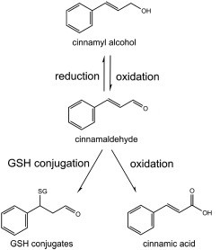

Figure : Cinnamaldehyde Metabolism adapted from Kiwamoto et al (2016)

The Kiwamoto model was adapted in a number of different ways. Firstly Kiwamoto *et al* (2016) wrote the model in the numerical ordinary differential equation solver Berkely Madonna (8.3.18 University of California at Berkeley, CA, USA). For this report a different solver was chosen. The model was coded in R (version 4.1.1) and R Studio (version 1.4.1717) using the Rxode (Fidler et al., 2022), ggplot2(Wickham, 2016) and PKNCA (Denney et al., 2015) packages. An explanation the code was adaptation process can be found in supplementary data 1; R code. R was chosen on the basis that R and R studio are open source, have a large assortment of publicly available add on packages, have the ability to perform global sensitivity analysis and lastly ability to perform population based modelling.

The following changes were made to the model code and structure. DNA adduct formation and CNMA-Glutathione (GHS) metabolism in the small intestine were removed for the human model as they were shown by (Kiwamoto et al., 2016) to not occur. Inhalation of CNMA into the lungs and subsequent distribution through the body was based on (Jongeneelen & Berge, 2011). This involves the inhalation of CNMA into an alveolar air compartment eq(1) + eq(3) from which CNMA is absorbed into the blood and enters circulation eq(2). CNMA can also re-enter the alveolar air and be exhaled eq(4). The complete model code and equations for both human and rat models can be found in supplementary data 1: R code.

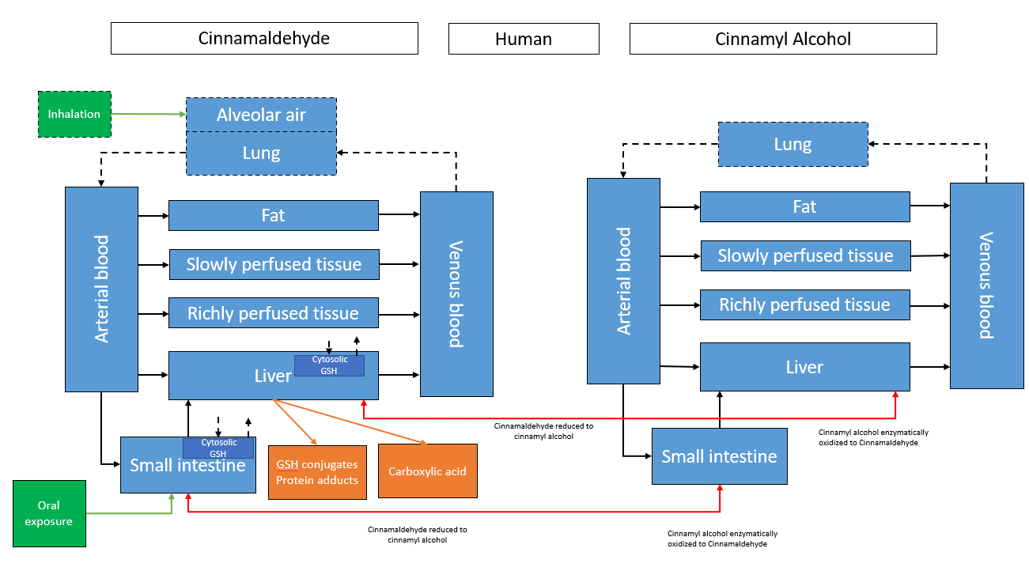

Figure : Structure of the inhalation CNMA model in Humans. Dotted lines represent additions to the model compared to Kiwamoto et al. Exposure routes are coloured green. Elimination routes are present in both the liver and small intestine and are coloured orange. In both the small intestine and the liver cytosolic Glutathione concentrations are modelled. Transformations of CNMA to Cinnamyl alcohol and back are represented by red lines.

Rate of Cinnamaldehyde inhalation (μmol/h)

$R\text{_Inhalation}$ $=P\text{_V}*\left(\frac{A\text{_inhalation_dose}}{\text{Volume_exposure_chamber }}\right)$ (1)

*P_V = Pulmonary ventilation (L/h)*

*A_inhalation_dose = The dose present in the exposure chamber* *(μmol)*

*Volume_exposure_chamber = the volume of the exposure chamber (L)*

Concentration of Cinnamaldehyde in Arterial blood leaving the lungs (μmol/L)

$\text{C_P_Art}\text{ = }\frac{\text{(}\text{Q_Pu} *\text{C_V + -R_Inhalation)}}{\text{(}\text{Q_Pu}\text{ +}\frac{\text{P_V}}{\text{P_B}})}$ (2)

*Q_Pu = blood flow to the lungs (L)*

*C_V = Concentration of CNMA in venous blood (μmol/L)*

*P_B = blood/air Partition coefficient (unitless)*

Concentration of Cinnamaldehyde exhaled (μmol/L)

$\text{C_Alvair}\text{ =}\frac{ \text{C_P_Art}}{\text{P_B}}$ (3)

Rate of Cinnamaldehyde exhalation (μmol/h)

(4)

* 1. Inhalation PBK model for CNMA in rats

To validate the inhalation compartment of the inhalation model the rat model from Kiwamoto et al (2016) was adapted as noted above. Not only was the model structure adapted all physiological and chemical parameters were checked and changed if necessary. The complete list of physiological parameters for the rat inhalation model can be found in Table 1. The physiological parameters are based on (Brown et al., 1997).

Table : Physiological parameters for the rat inhalation model.

|  |  |  |  |  |
| --- | --- | --- | --- | --- |
| Parameter | Description | Value | Unit | Reference |
| BW  Tissue volumes | Body Weight | 0.25 | Kg | (Brown et al., 1997) |
| V_F | Fat | 0.0175 | L | *“”* |
| V_L  V_SI  V_A  V_V  V_RP  V_SP  V_Pu  Cardiac parameters  Q_C  Q_F  Q_L  Q_SI  Q_RP  Q_SP  Q_Pu  Uptake  P_V  Ka | Liver  Small intestine  Arterial Blood  Venous Blood  Richly perfused  Slowly perfused  Lung  Cardiac output  Fat  Liver  Small intestine  Richly perfused  Slowly perfused  Lungs  Pulmonary ventilation  Uptake rate constant | 0.0085  0.0035  0.00475  0.01475  0.00925  0.169  0.00125  5.4  0.07  0.13  0.12  0.64  0.17  Q_C  0.75  1.97 | L  L  L  L  L  L  L  L/h  L/h  L/h  L/h  L/h  L/h  L/h  L/h  Per hour | *“”*  *“”*  *“”*  *“”*  *“”*  *“”*  *“”*  *“”*  *“”*  *“”*  *“”*  *“”*  *“”*  *“”*  (Brown et al., 1997) based on a mean of 50ml/min per 100g  Calculation based on (Ans et al, 2022) |

As noted in Table 1 the uptake rate constant was calculated based on Punt et al,(2022). The calculation that were used are displayed below.

Apparent permeability

$Log P_{app}(\text{cm/s)}= -4.36-0.01*TPSA$ (5)

*TPSA = Topological polar surface area of CNMA = 17.1 Computed by Cactvs 3.4.8.18 (PubChem release 2021.05.07)*

Effective permeability

$Log P_{eff}\left(10\text{^-}4 \text{cm/s}\right)= 0.4926*\log{P_{app}}(10\text{^-6 cm/s) }-0.1454$ (6)

Uptake rate constant

$Ka (\text{/h)}=\frac{P_{eff}\text{(cm/s)}*2}{R\left(cm\right)*3600(\text{s/h)}}$ (7)

*R = intestinal radius in cm = 0.126* (Kothari & Rajagopalan, 2020)

The movement of CNMA through the body is governed by partition coefficient that describe the partitioning of CNMA between different compartments. A central partition coefficient is the octanol water partition coefficient, logKow this was calculated using EPIsuite (Version 4.5 SP1). The organ blood partition coefficients where calculated based on the LogKow using (Dejongh et al., 1997). The blood air partition coefficient was not present in the oral uptake model and thusly had to be defined. This was calculated using the method provided by (Jongeneelen & Berge, 2011). This method estimates the blood/air partition coefficient based on a dimensionless Henry coefficient that was calculated as is shown in eq(8). Eq(9) uses the Henry coefficient in combination with the octanal:air partition coefficient to estimate a blood:air partition coefficient. A complete list of partition coefficients used for the rat inhalation model can be found in Table 2.

Dimensionless Henry coefficient

$\frac{\text{(CNMA_vapour_pressure * CNMA_Molecular_weight) }}{\text{(CNMA_water_solubility * CNMA_gas_constant * temp)}}$ (8)

*Vapour pressure = 0.0337 (mmHg)*

*Molecular weight = 132.16*

*Water solubility = 2150 (mg/l)*

*Gas constant = 3.45*10^-6 (atm-m3/mole)*

Blood : air partition coefficient

$\frac{0.4445}{Henry DL}+0.005189*K_{oa}$ (9)

*Koa = octanal/air partition coefficient = 13.18 (EPIsuite Version 4.5 SP1)*

Kiwamoto *et al* also used Episuite and the method described by Dejongh *et al* (1997) to calculate the partition coefficients yet some values do not agree as can be seen in Table 2. Sadly, Kiwomato *et al* (2016) provides no specifics as to how they were derived and thusly the reason for the difference remains unclear. Partition coefficient calculates used for this report can be found at [*https://github.com/jjLugt/Cinnamaldehyde-pbk/blob/main/QSAR%20calculations.R*](https://github.com/jjLugt/Cinnamaldehyde-pbk/blob/main/QSAR%20calculations.R).

Table : Partition coefficients for CNMA and Cinnamyl alcohol used in the rat inhalation model. Values as used in Kiwamoto et al (2016) added for comparison.

|  |  |  |  |  |
| --- | --- | --- | --- | --- |
| Partition coefficient | Description | Value | Kiwamoto | Reference |
| P_F  P_L | Fat:Blood  Liver:Blood | 17.42  1.18 | 14.2  1.21 | (Dejongh et al., 1997) |
| P_SI  P_RP  P_SP  P_PB  P_Pu  Cinnamyl alcohol  P_OH_F  P_OH_L  P_OH_SI  P_OH_RP  P_OH_SP  P_OH_Pu | Small intestine:Blood  Richly perfused:Blood  Slowly perfused:Blood  Blood:Air  Lung:Blood  Fat:Blood  Liver:Blood  Small intestine:Blood  Richly perfused:Blood  Slowly perfused:Blood  Lung:Blood | 1.18  0.81  0.39  1.81  1.18  1.71  0.81  0.81  0.81  0.39  1.81 | 1.21  1.21  0.57  NA  NA  14.6  1.22  1.22  1.22  0.57  NA | “”  “”  “”  “”  (Jongeneelen & Berge, 2011)  (Dejongh et al., 1997)  “”  “”  “”  “”  “” |

The last group of parameters that has yet to be defined are the parameters that are associated with metabolism of CNMA, Cinnamyl alcohol and Glutathione. As Kiwamoto et al (2016) experimentally derived these parameters they were used as is. A Complete overview of these metabolic parameters can be found in supplementary data 2: parameters.

* 1. Single human male inhalation model

The same general approach was used as with the rat models. This means adopting the parameters as used by Kiwamoto *et al* (2016), supplementing these parameters with additional parameters as needed and the addition of the above described inhalation compartment. Physiological parameters were derived from IRCP values (Alexaklrin Obninsk et al., 2003).

Table Physiological parameters for the single human male inhalation model.

|  |  |  |  |  |
| --- | --- | --- | --- | --- |
| Parameter | Description | Value | Unit | Reference |
| BW  Tissue volumes | Body Weight | 70 | Kg | (Alexaklrin Obninsk et al., 2003) |
| V_F | Fat | 15 | L | *“”* |
| V_L  V_SI  V_A  V_V  V_RP  V_SP  V_Pu  Cardiac parameters  Q_C  Q_F  Q_L  Q_SI  Q_RP  Q_SP  Q_Pu  Uptake  P_V  Ka | Liver  Small intestine  Arterial Blood  Venous Blood  Richly perfused  Slowly perfused  Lung  Cardiac output  Fat  Liver  Small intestine  Richly perfused  Slowly perfused  Lungs  Pulmonary ventilation  Uptake rate constant | 1.8  0.6  1.4  4.1  3.4  43.1  0.5  390  5.2  14.1  8.6  47.3  24.8  Q_C  540  0.62 | L  L  L  L  L  L  L  L/h  L/h  L/h  L/h  L/h  L/h  L/h  L/h  Per hour | *“”*  *“”*  *“”*  *“”*  *“”*  *“”*  *“”*  *“”*  *“”*  *“”*  *“”*  *“”*  *“”*  *“”*  (Alexaklrin Obninsk et al., 2003)  (Punt, 2022)  R = 1.26 cm (Helander & Fändriks, 2014) |

The human partition coefficients were calculated in a similar manner as the rat partition coefficients. The LogKow values were calculated using EPIsuite (Version 4.5 SP1). Based on the LogKow the partition coefficients where calculated using both (Dejongh et al., 1997; Jongeneelen & Berge, 2011). The uptake rate Ka was calculated using Punt *et al* (2022) with an intestinal radius of 1.26 cm (Helander & Fändriks, 2014) . Similar unexplained differences between partition coefficients could be found as. A complete list of parameters as sued for the human oral/inhalation models can be found in the supplementary data 2: parameter

Table : Human partition coefficients for CNMA and Cinnamyl alcohol used in the single human inhalation model. Values as used in Kiwamoto et al (2016) added for comparison.

|  |  |  |  |  |
| --- | --- | --- | --- | --- |
| Partition coefficient | Description | Value | Kiwamoto | Reference |
| P_F  P_L | Fat:Blood  Liver:Blood | 47.75  1.83 | 39.3  2.04 | (Dejongh et al., 1997) |
| P_SI  P_RP  P_SP  P_PB  P_Pu  Cinnamyl alcohol  P_OH_F  P_OH_L  P_OH_SI  P_OH_RP  P_OH_SP  P_OH_Pu | Small intestine:Blood  Richly perfused:Blood  Slowly perfused:Blood  Blood:Air  Lung:Blood  Fat:Blood  Liver:Blood  Small intestine:Blood  Richly perfused:Blood  Slowly perfused:Blood  Lung:Blood | 1.81  1.81  1.5  0.29  1.81  49.26  1.18  1.18  1.18  1.53  1.18 | 2.04  2.04  1.57  NA  NA  40.5  2.09  2.09  2.09  1.60  NA | “”  “”  “”  “”  (Jongeneelen & Berge, 2011)  (Dejongh et al., 1997)  “”  “”  “”  “”  “” |

And lastly for the metabolic parameters they were derived by Kiwamoto et al (2016) and thusly they were used as is. A Complete overview of these parameters can be found in supplementary data 2: parameters.

* 1. Human population based PBK model

To more accurately model possible variation between individuals, it was decided to create a population based model. Instead of modelling a single individual population based modelling runs the same model many different times each time with a different parameter set to represent different individuals from a population. The base model used is the same as for the single human inhalation model and can be seen in Figure 2. As the basis for the population parameters the Popgen webservice was used. Popgen is a web based application which generates a population of individuals with necessary parameters for pbk modelling based on several initial parameters (Willmann et al., 2007). Using Popgen two data sets consisting of 1000 individuals were generated. One female data set and one male data set. The initial population generation parameters can be found in supplementary data: 2 paramters.

Popgen does not include alle necessary parameters required for the inhalation model and was missing pulmonary ventilation and values for a blood compartment. Pulmonary ventilation was derived using ICRP values (Alexaklrin Obninsk et al., 2003). The male value for the data set is based on a normal distribution and 3 standard deviations (99.7%) of variance based on the male mean of 540 L/h. the female value for the data set is based on a normal distribution and 3 standard deviations (99.7%) of variance based on the female mean of 390 L/h. Blood compartment volumes were based on calculations shown in (Price et al., 2003). The calculation used is eq(10) based on this total blood volume 2/3 was defined as arterial blood and 1/3 as venous blood.

Blood volume (L)

$\left(\frac{13.1 * Height + 18.05 * Body Weight - 480}{0.5732} \right)/1000$ (10)

A complete overview of parameters and calculations can be found in the supplementary data 2: parameters. The integration of the generated female and male data sets can be found in supllementary data 1: R code under the header “human population model parameters”

* 1. Model validation

A PBK model attempts to predict tissue concentrations based on a host of different parameters. To ascertain if such a model accurately predicts this tissue concentration the preferred method is to compare model output to relevant *in vivo* data. Such an approach was used by Kiwamoto *et al* (2016) as there is oral exposure data available for rats and limited data for humans. As this report is interested in inhalation exposure *in vivo* exposure data is preferred to validate the model. Unfortunately, exceedingly little inhalation exposure data that is coupled with PBK relevant parameters is available in either human or rats (plasma concentration, tissue concentrations etc). In order to bridge this gap a read across approach using the similar chemical Benzaldehyde was considered. Unfortunately, this chemical is similarly data poor and thus could not be used. As no inhalation data is available for either rats or humans and a chemical read across wasn’t possible either validation of this model will be purely based on oral absorption performance.

* 1. Route to route extrapolation

A plausible exposure scenario for use with the human models was constructed based on limited data from Electronic cigarette liquids (Khachatoorian et al., 2022). Exposure was modelled as being a three minute ‘smoke’ break using an Electronic cigarette every 30 minutes for 6 hours. A total of 12 exposures. As Khachatorian et al (2022) has shown that an Electronic cigarette user consumes on average 567 mg of Electronic cigarette liquid per session. If we assume a worst-case scenario with a CNMA concentration of 343 mg/ml (Omaiye et al., 2019) this would yield an exposure of 197.6 mg of CNMA per session. For an average person weighing this would yield approximately 2.8 mg/kg-BW per smoking session.

1. Global sensitivity analysis

PBK models use a large set of parameters not all of which have a large impact on model outcome. Knowing which parameters have an significant impact on model outcome allow a model user to ensure those parameters are defined as accurately as possible (Hsieh et al., 2018). Furthermore, the important parameters can be analysed for abnormalities which can help in the quest for discovering hidden errors in the code. To evaluate the sensitive parameters of the single human and rat models global sensitivity analyses (GSAs) where performed. This was done using a method demonstrated by Kasteel *et al* (2021) (Kasteel et al., 2021). This involves the `soboljansen` function from the Package `sensitivity´ (Bertrand Iooss et al., 2022). This method requires the following input.

Two parameters set which serve as upper and lower bounds. These two parameter sets were generated based on the single human parameter set. As an upper bound the parameter values +1% and as a lower bound the parameter values -1% where used. Between these bounds the parameter values assumed to be normally distributed. The soboljansen function will then generate a large data set of possible parameter combinations and will run the model using these parameter combinations. The output of these runs will then be compared to evaluate the impact on the outcome of the model when parameters are changed. The output of this analysis is a ranking of influential parameter using two indexes. The total effect and main effect. The total effects have cumulative value of 1 representing the contribution of a parameter to the overall change in output of interest. The main effect similarly has a cumulative value of 1 representing the contribution of this parameter independent of its effects on other parameters. To illustrate body weight. Body weight is expected to have a large total effects as a large number of parameters such as organ volumes, cardiac output and so on are influenced by body weight. Yet, it is expected that body weight does not necessarily directly have a large impact on CNMA concentration and thusly a smaller main effect is expected. The total and main effects for alle parameters were investigated at multiple time points for both oral and inhalation exposures. The corresponding code can be found in the supplementary data section 1: R code. Or alternatively on https://github.com/jjLugt/Cinnamaldehyde-pbk .

1. Results
   1. Global Sensitivity analysis

As noted above GSA can be a valuable tool in both checking the model for errors as ensuring correct parameters are used. As the outcome of a model is both dependent on exposure dose and exposure route multiple GSAs have been performed for both rat and human models.

In rats the sensitive parameters determining the CNMA concentration in blood with oral and inhalation exposure were investigated. The results are presented in Figure 3 and Figure 4. During oral exposure the two most important parameters excluding T= 30 min where the uptake rate constant (Ka) and cardiac output (QC). At T=30 min the initial concentration of GHS in the liver (init_GSH_L) is the second most important parameters followed by the first order rate constant for the conjugation GSH with CNMA(k_L_GST). It can be noted that after 90 min the P_B (partition coefficient between air and blood for CNMA) and P_V (pulmonary ventilation )steadily increase in relevance. BW (Body weight) has a moderate impact at all time points. The sensitive parameters for inhalation exposure are noted to be considerably different. The two most important parameters are P_B followed by BW. Both Q_RP (blood flow to Richly perfused tissue) and V_SP (volume of slowly perfused tissue) are moderately important at all time points.

Sensitive parameters might change if an exposure route is changed. To test if this was the case for the human oral and human inhalation models GSA results for a 250 mg/kg-dose were compared. It can be noted that two different sensitive parameter sets appear as can be seen in Figure 4. With the three most important sensitive parameters as ranked by number of appearances in the top three position for oral exposure being: Vsmax_L_CA (maximal rate for oxidative reduction of CNMA in the liver) , Ka (Uptake rate) and Q_C (cardiac output) and for inhalation exposure: P_V (pulmonary ventilation), P_B (blood:air partition coefficient for CNMA) and V_SP ( Volume of slowly perfused tissue). In oral exposure at all time points nearly half of all variation in the model is explained by the rate of oxidation of CNMA in the liver. In contrast it can be noted that during inhalation exposure no metabolic parameters are present in the top ten influential parameters.

As the lungs are a expected sensitive organ during inhalation exposure sensitive parameters were determined for a 2.8 mg/kg-BW exposure and a 250 mg/kg-BW exposure. the results of these GSAs can be found in Figure 5. The top three sensitive parameters are the same for 2.8 and 250 mg/kg-BW inhalation exposures. The parameters are: P_V (pulmonary ventilation), P_B (blood:air partition coefficient for CNMA) and either P_Pu (Blood:lungs partition coefficient for CNMA) or V_SP ( Volume of slowly perfused tissue). Indicating that the concentration is mainly dictated by the inhalation dynamics absorption in blood and transfer into the lungs during the first 90 min and afterwards appears to also be influenced by possible reservoir in slowly perfused tissue.

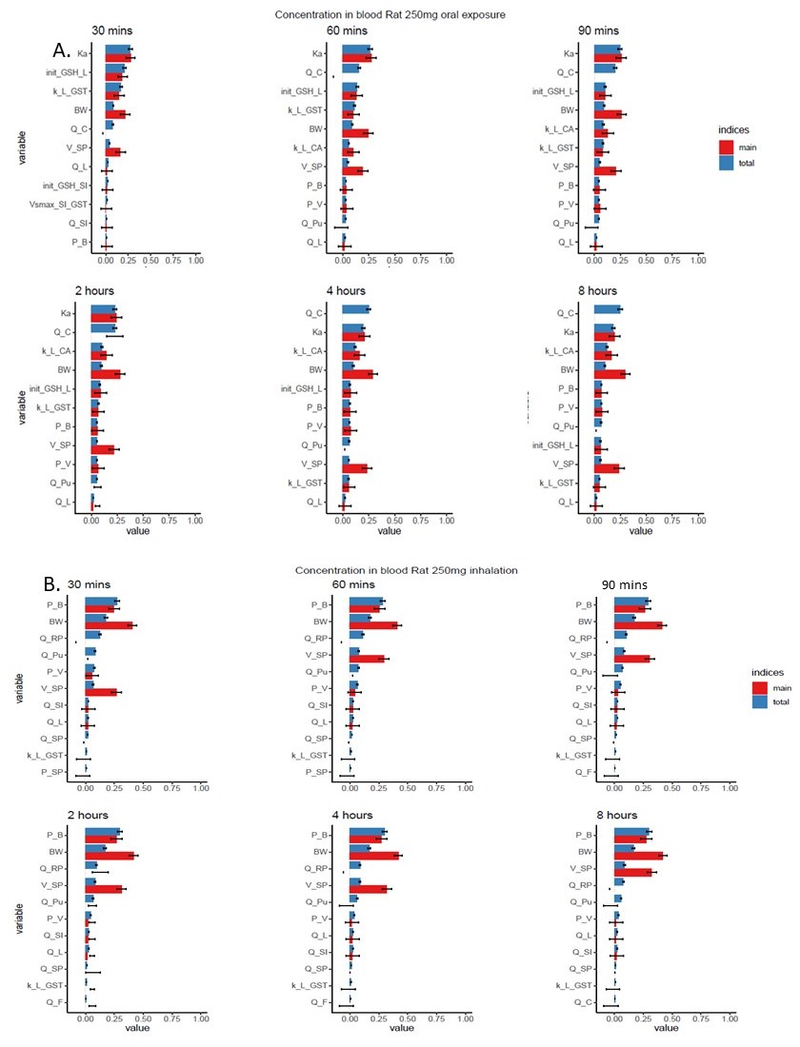

Figure : Global sensitivity analyses results for CNMA exposure after either an inhalation or oral exposure in rat 250 mg/kg-BW. (A) Top ten sensitive parameters influencing the concentration of CNMA in the liver.(B) top ten sensitive parameters influencing the concentration of CNMA in blood . Error bars indicate the 95% confidence interval.

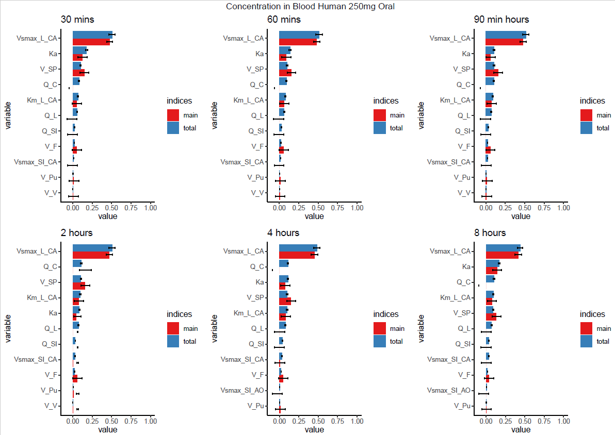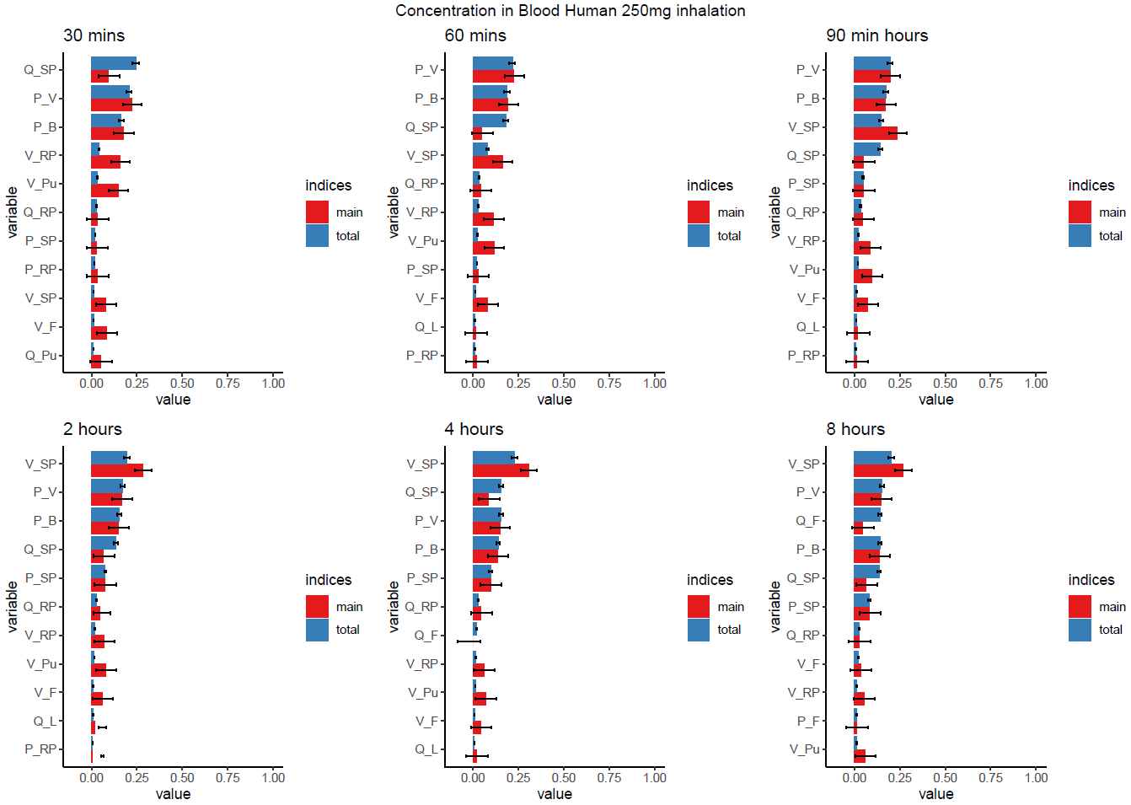

A.

B.



Figure : Global sensitivity analyses results for oral and inhalation exposure with the human model. (A) Top ten sensitive parameters for CNMA concentration in blood after an oral exposure to a 250 mg/kg-BW dose. (B) Top ten sensitive parameters for CNMA concentration in blood after an inhalation exposure to a 250 mg/kg-BW dose. Error bars indicate the 95% confidence interval.

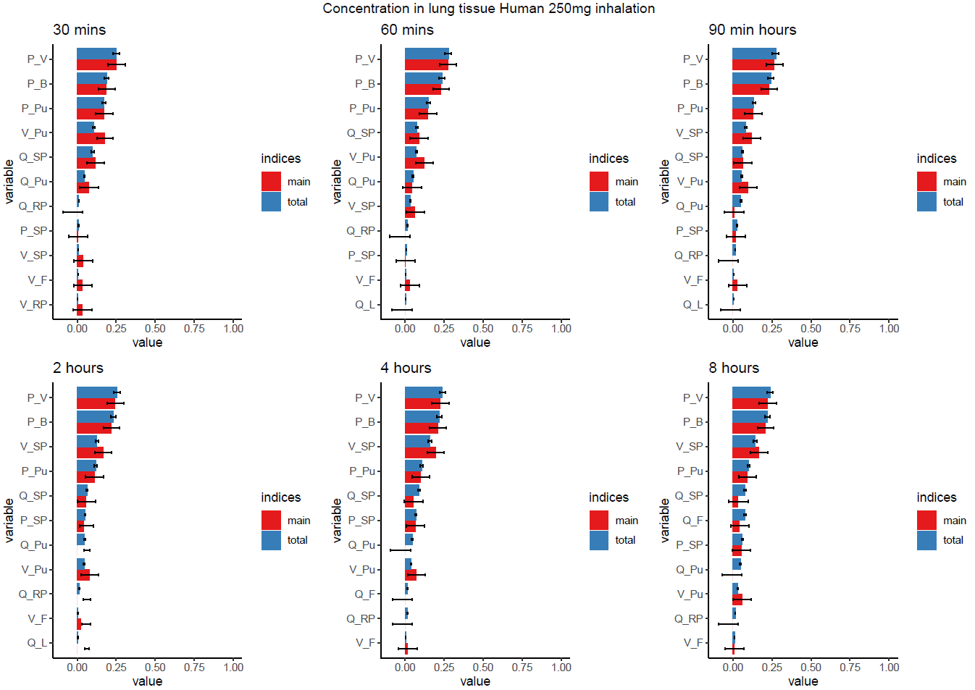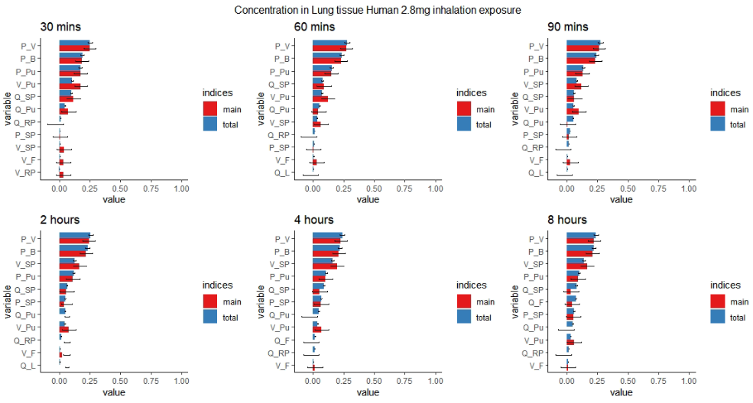

A.

B.

Figure : Global sensitivity analyses results for inhalation exposure with the human model. (A)Top ten sensitive parameters for CNMA concentration in the lungs after an inhalation exposure to a 2.8 mg/kg-BW dose (B) Top ten sensitive parameters for CNMA concentration in the lungs after an inhalation exposure to a 250 mg/kg-BW dose. Error bars indicate the 95% confidence interval.

* 1. Evaluation Rat model

As the inhalation model is based on an existing oral exposure model the first objective was seeing if it was possible to recreate the results of the oral exposure model using the new oral exposure model in R code. In order to do this oral and IV exposure data was used from the literature. Different exposure doses are available from literature these include 500 mg/kg-BW, 250 mg/kg-BW oral exposures (Yuan et al., 1992; Zhao et al., 2014) already considered in the Kiwamoto *et al* (2016) report and more recent pharmacokinetic study’s concerning 375 mg/kg-BW, 15 mg/kg-BW and 50 mg/kg-BW exposures(Dong et al., 2022; Ji et al., 2015; Yong et al., 2020). Lastly two IV exposures will be considered 10 and 20 mg/kg-BW (Shetty et al., 2020; Zhao et al., 2014). The plasma concentration of CNMA as measured in (Zhao et al., 2014) (Zao) and (Yuan et al., 1992)(RAT_1,2,3) are presented in Figure 5. Also presented in Figure 5 are the simulation results as presented in Kiwamoto et al (Kiwa) and the simulation results found when running the inhalation model (SIM). As expected the results of the Kiwamoto model and the inhalation model can be seen to differ substantially with a Cmax value of 829 μmol/L and 116 μmol/L respectively. A 7.15 fold higher Cmax value with the Kiwamoto model. To evaluate whether this difference was due to errors in the R code a new simulation was run this time using all of the parameters as specified in Kiwamoto *et al* (2016)(SIM kiwa). This resulted in a Cmax value of 769 μmol/L or a 0.93 fold difference compared to Kiwamoto. The inhalation model performance compared to the experimental data found in Yao et al. A 6.56 fold difference can be found between the inhalation model 116 μmol/L)and the Yao data 17.69 μmol/L. This represents an improvement compared to model performance found in Kiwamoto et al from 56 fold to 6.56 fold. As the model still overpredicts in the time points shortly after exposure. Another model run was done with a reduced absorption rate constant to simulate a slower uptake rate in the small intestine. This resulted in a inhalation model Cmax 13.81 μmol/L that was 0.78 fold that of the Yao data 17.60 μmol/L. The remaining data is presented in, in this figure predicted vs outcome plots are presented for the different exposures. If relevant the results of the inhalation model with adapted Ka are also shown. To compare the results between the inhalation model and adapted model the root mean square deviations (RSMD) are shown. This is a measure of the size of the deviation from the observed values.

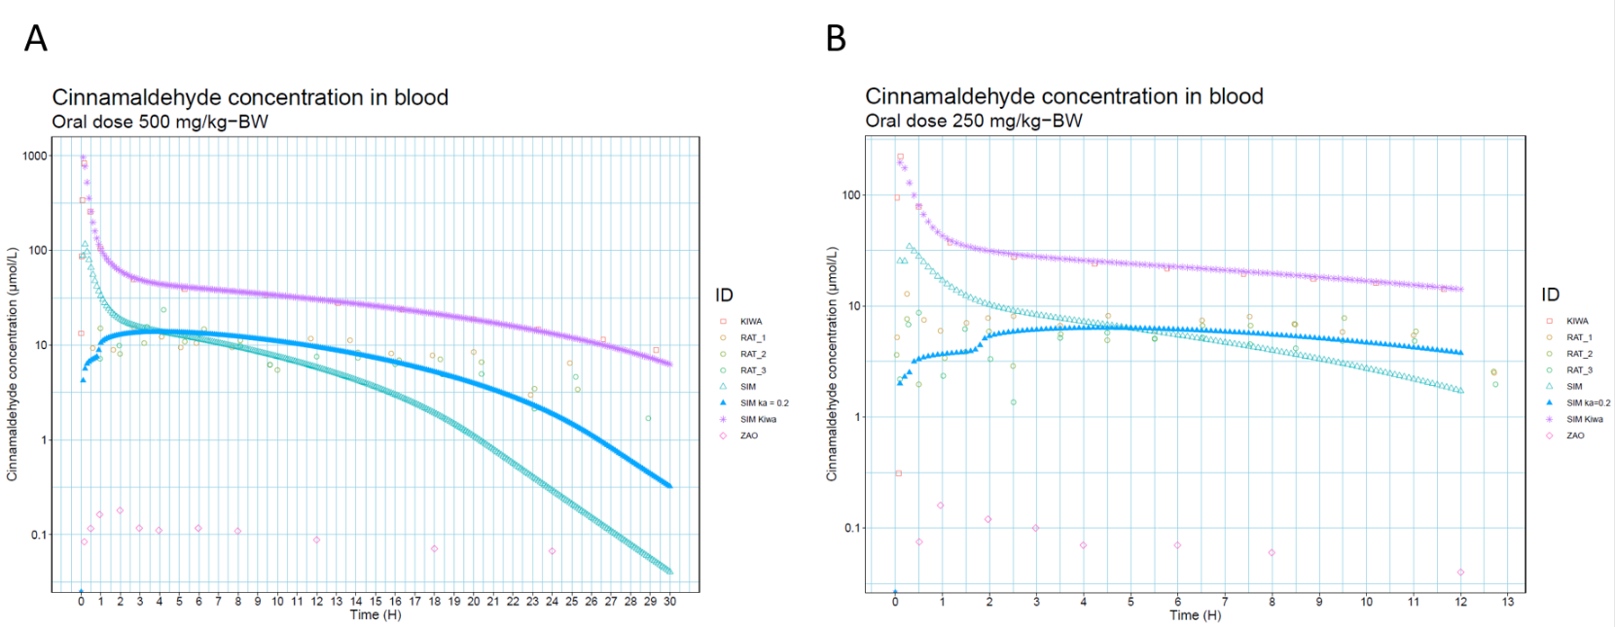

Figure : CNMA blood concentration comparison between simulated data and Kiwamoto. (🞏)The purple squares are the simulation data form Kiwamoto et al. (○) Yuan et al data is represented by the Rat 1-3 points. (△) R model simulation data is represented by the SIM line.(▲) R model simulation data with fitted Ka of 0.2 is represented by the SIM ka = 0.2 line.(◊) Zao et al data is represented by Zao data points. (🞻)R model with Kiwamoto parameters is represented by SIM kiwa.

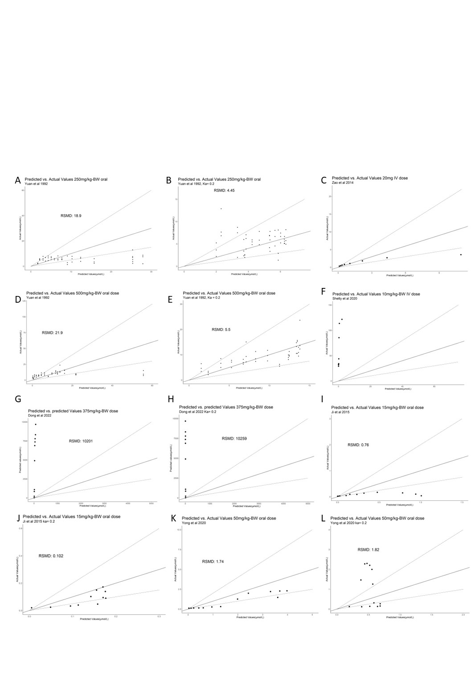

Figure : Predicted vs outcome plots of experimental data compared to the inhalation model in R. Plots (A,B,D,E,G,H,I, J, K, L) show oral data. Plots (C and F) show IV data. The diagonal solid lines in the graph represents the line at which predicted vs actual values are one 1. The dotted lines represent a 2 fold difference. To compare similar exposure the Root square mean deviation (RSMD) is added.

The higher the RSMD the worse a model corresponds to the observed data. Adapting the model with a reduced Ka value improved model performance in 3 of the 5 cases with oral absorption and had a negligible or slight negative impact on the remaining two cases. With 500, 250, 20 and 15 mg/kg-BW doses most data points where within a 2 fold difference of the observed values. 50 mg/kg-BW values remained within a 5 fold difference and 15 mg/kg-BW doses within a 10 fold difference. 375 and 10 mg/kg-BW doses differed greatly from predicted values

Table : Table showing the results of a 250 mg/kg-BW dose in the single rat inhalation model. Exposure route either oral or inhalation.

|  |  |  |  |  |
| --- | --- | --- | --- | --- |
| Rat | Cmax ( $µmol/l)$ | Tmax (h) | AUC->last  (µmol/l-h) | AUC->inf  (µmol/l-h) |
| **Oral**  Small intestine | 1384.1 | 0.1 | 796.65 | 796.7 |
| Liver  Blood  Lung  Fat  Richly perfused tissue  Slowly perfused tissue  **Inhalation**  Blood  Lung  Fat  Richly perfused tissue  Small intestine  Slowly perfused tissue  Liver | 92.2  60.84  30.37  30.37  26.94  8.3  14.75  10.48  10.48  9.28  5.54  3.06  1.32 | 0.3  0.3  0.3  0.3  0.3  0.4  0.8  0.5  0.5  0.6  0.6  0.7  0.39 | 227.01  163.32  81.52  81.52  72.23  24.05  188.45  130.4  130.4  115.42  73.67  38.19  21.8 | 227.26  165.51  81.62  81.62  72.31  24.08  227.22  157.1  157.1  139.06  86.63  46.05  26.59 |

Table : Table showing the results of a 250 mg/kg-BW dose in the single human inhalation model. Exposure route either oral or inhalation.

|  |  |  |  |  |
| --- | --- | --- | --- | --- |
| Human | Cmax ( $µmol/l)$ | Tmax (h) | AUC->last  (µmol/l-h) | AUC->inf  (µmol/l-h) |
| **Oral**  Small intestine | 2982.11 | 0.1 | 3521.35 | 3521.7 |
| Fat  Liver  Blood  Lung  Richly perfused tissue  Slowly perfused tissue  **Inhalation**  Fat  Richly perfused tissue  Lung  Blood  Slowly perfused tissue  Small intestine  Liver | 0.44  6.33  1.8  0.49  0.47  0.22  81.89  57.55  57.59  48.69  30.74  7.48  0.14 | 4.5  0.1  0.2  0.2  0.3  0.9  5.8  0.2  0.1  0.2  1.1  0.2  0.2 | 8.43  7.83  2.4  0.65  0.65  0.54  1566.02  121.88  120.64  117.19  101.27  15.51  0.29 | 17.34  7.88  2.4  0.66  0.66  0.54  3261.41  122.44  121.2  119.49  101.72  15.59  0.29 |

* 1. Interspecies comparison.

The human model has no major changes to model structure that would lead to differences in simulation outcome compared to the rat model. The differences between the models is mainly in the specific input parameters concerning partition and physiological parameters. Table 5 and Table 6 shows the results of 4 simulations consisting of an oral and an inhalation exposure to both the single human and single rat model. When oral exposure is considered between human and rat simulation results a similar picture emerges. A very high AUC value for the primary exposed organ small intestine followed by the liver. The liver is directly linked to the small intestine in this model so this was expected. Followed by AUC values in the rest of the organs that are at least an order of magnitude lower in humans compared to rat. If we compare inhalation exposure between human and rat simulation results differ more compared to oral exposure. The organ with the highest Cmax and AUC value in rat is blood in the human model humans this is fat.

Figure : Percentage of 0.7 mg/kg-BW oral dose metabolized to cinnamic acid metabolites using the Human population based model. Individual male and female results are represented as blue and red dots respectively.

* 1. Human model evaluation

In order evaluate the performance of the single and population based inhalation model only very limited metabolic data is available. In the study two male participants were given 0.7 mg/kg-BW CNMA orally. This resulted in 96.2% and 96.5% of the administered dose being excreted in the urine as hippuric acid, benzoyl glucuronide, 3- hydroxy-3-phenyl propionic acid or benzoyl acid all of which are downstream products of the Cinnamic acid metabolite (Maria & Peters, 1993) . In Figure 7 the results of 0.7 mg/kg-BW oral exposure simulation using the human population model can be seen. The median percentage metabolized for both females and males 97.6% after 24h. with 99.72% of results laying between 98.42% and 96.3%.

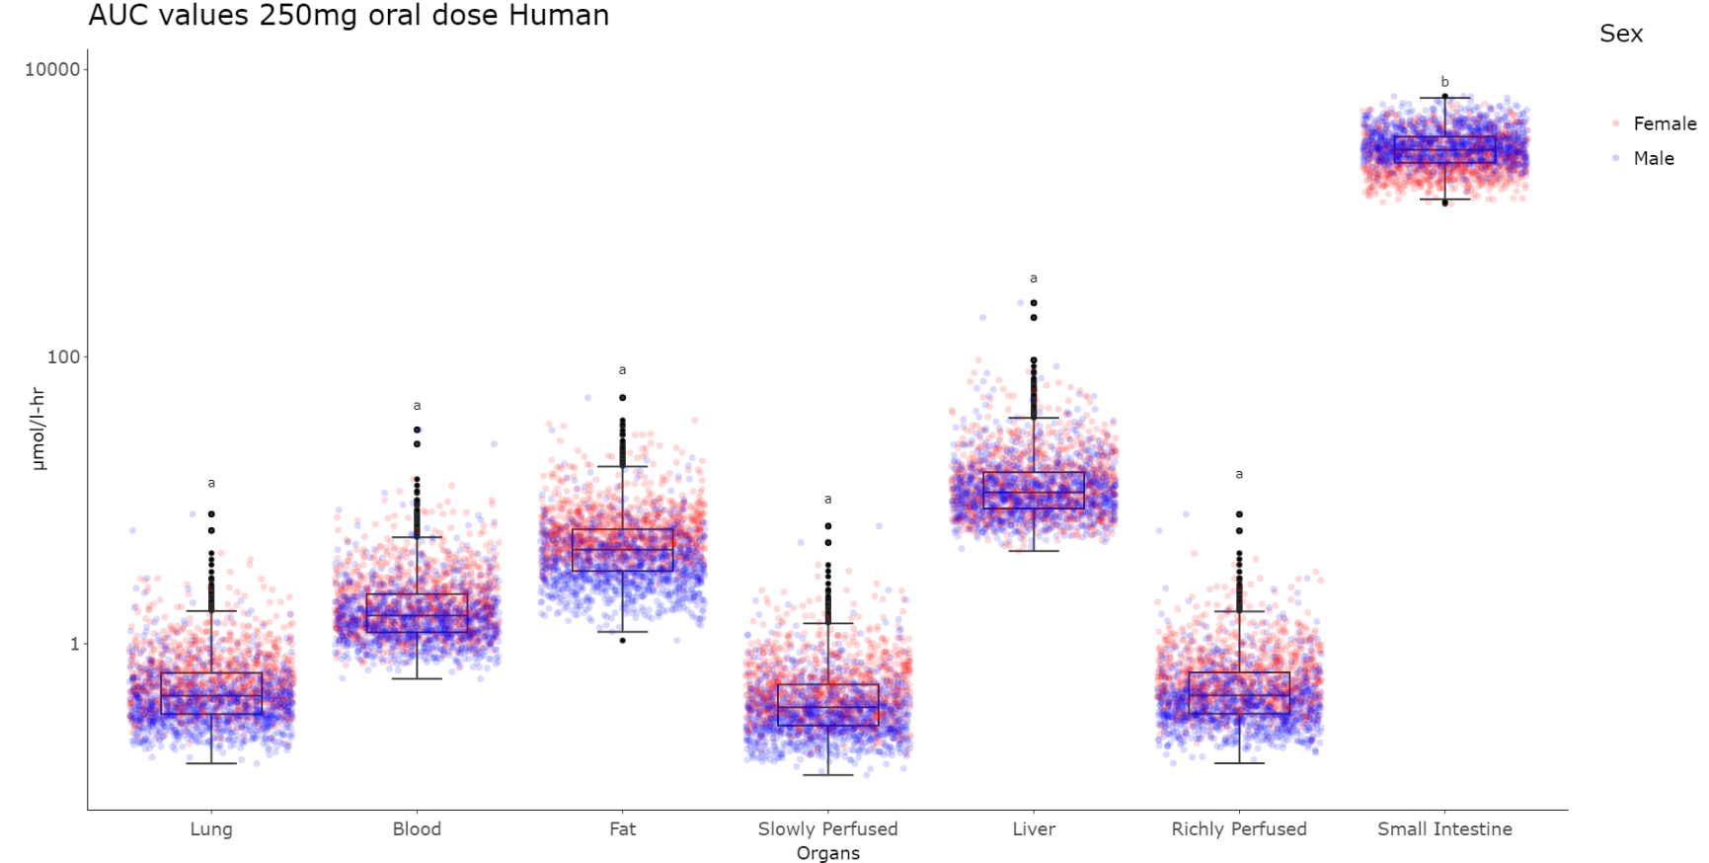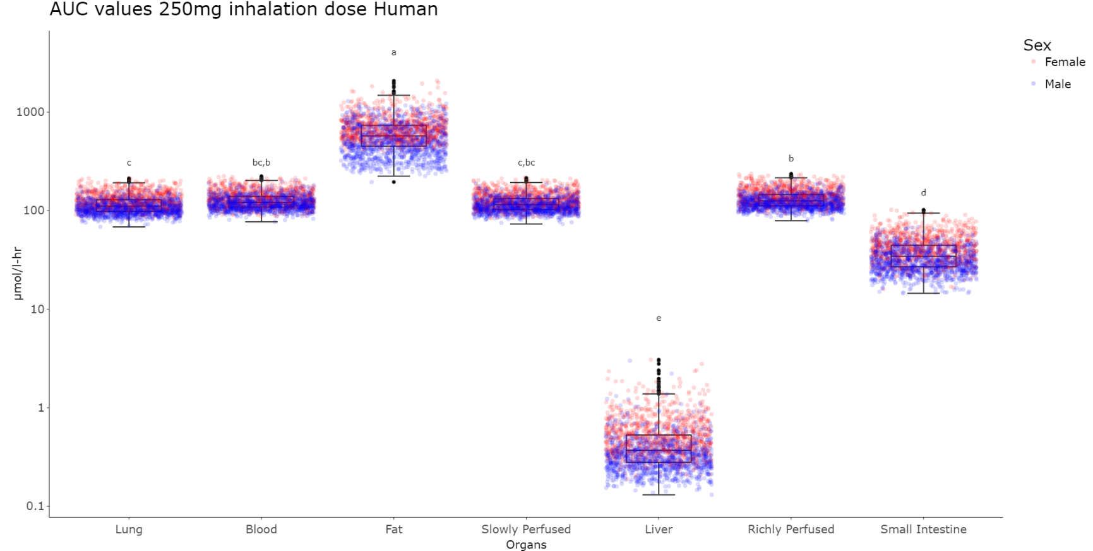

Figure : Area under the curve value results for a 250 mg/kg-BW and inhalation dose using the human inhalation population model. Significance differences were calculated between the different organs. Organs that do not differ significantly share the same significance letter. If two significancy letters are present the first one represents female results and the second male results. Inter-organs differences where tested using Tukey HSD tests (P>0.05). inter-sex differences where tested using both Tukey HSD test and Welch-t tests (P>0.05). In al organs there was a significant difference between male and female results

As no read across of *in vivo* data was possible due to lack of data no further validation steps were performed. In order to evaluate whether inhalation exposure leads to differences in sensitive organs two simulation where performed. In Figure 8 the results of these simulation can be seen. Populations where simulated as being exposed once to either an oral or inhalation dose of 250 mg/kg-BW. The concentrations of the various organs were then collected between 0 and 24 hours. Firstly, as the simulations where ran with both a female and a male data set the results of these simulations were compared. Specifically, the mean values of these results were compared using Tukey HSD and a Welch T test. In all cases the male and female values differed significantly (P>0.05). With exception of the small intestine during oral exposures AUC values for females were higher than for males. If we consider the differences between exposure methods it can be observed that there are considerable differences. Mean CNMA AUC values for both males and females during inhalation exposure where higher in the following organs. Lung (252.6 fold), Blood(76.6 fold), Fat(126.6 fold), Slowly perfused tissue(318.8 fold) and Richly perfused tissue(284.5). Mean CNMA AUC values for both males and females were lower in the following organs; Liver(30.1 fold) and small intestine(75 fold). As a singular 250 mg/kg-BW inhalation dose is not representative of normal exposures during electronic cigarette usage, repeat dosing of 2,8 mg/kg-BW as described in 2.7 “Route to route extrapolation” was simulated. The results of this simulation are presented in Figure 9.

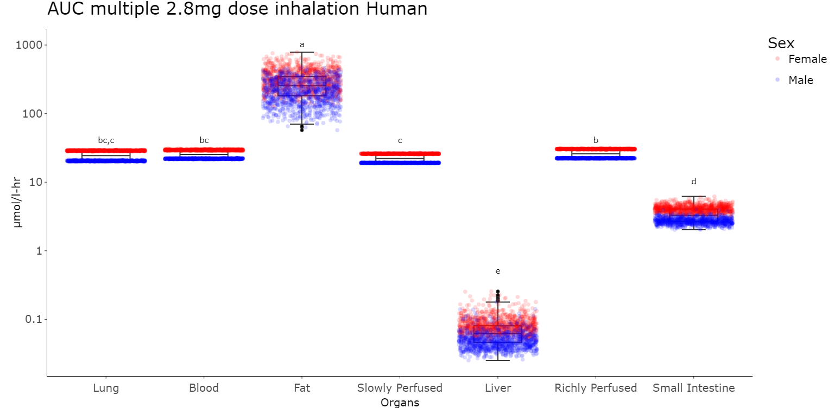

Figure : Area Under the Curve simulation results for Human population model based on multiple 2.8 mg/kg-BW inhalation exposures. Significance of differences were calculated between the different organs. Organs that do not differ significantly share the same significance letter. If two significancy letters are present the first one represents female results and the second male results. Inter-organs differences where tested using Tukey HSD tests (P>0.05). inter-sex differences where tested using both Tukey HSD test and Welch-t tests (P>0.05). For all organs there was a significant difference between males and female results.

Similar steps were performed as before. Inter sex comparisons shown significant differences in the mean CNMA AUC values between females and males with higher values observed in female simulations. When compared to 250 mg/kg-BW inhalation, multiple inhalation exposures to 2.8 mg/kg-BW yielded the following results. CNMA AUC values were lower in all organs Lung (4.5 fold), Blood(4.7 fold), Fat(2.2 fold), Slowly perfused tissue(5.12 fold), Richly perfused tissue(4.8), Liver(6.2) and Small Intestine(10.4 fold). The general distribution over organs was similar to 250 mg/kg-BW inhalation with the highest concentrations noted in fat. Cmax results can be found in Supplementary data 3: supplementary graphs.

In the context of exposure to electronic cigarette smoke the first organ to be exposed and the organ most associated with adverse effects of cigarette smoke are the lungs. Using the human population based inhalation model, the CNMA concentration in lung tissue was simulated after multiple exposures to 2.8 mg/kg-BW. The results of this simulation can be seen in Figure 10. After the start of exposure the CNMA concentration in the lung rapidly increases to a maximum of around 32 μmol/l after which it rapidly decreases in about 30 min to zero. Inter individual variation in results are modest for the exposure peak the lower bound is 29.3 μmol/l, the mean is 32.8 μmol/l and the upper bound is 39.0 μmol/l. This variation is not evenly distributed between genders as can be seen in Figure 9 with female individuals CNMA concentrations being significantly higher than male individuals

Figure : CNMA Lung tissue concentration after multiple 2.8 mg/kg-BW inhalation doses human population model. In red the mean concentration of CNMA in venous blood is represented the dotted lines represent the 95% confidence interval boundaries.

4. Discussion

This report presents an human population inhalation model for exposure to CNMA. Population models allow a researcher to more accurately predict chemical concentrations in the general public. This is especially pertinent in the case CNMA as its use in electronic cigarette devices has not been comprehensively studied and thus *in vivo* data is still missing. This population model was based on real population data using the online tool Popgen. The pharmacokinetic parameters such as logKow and the partition coefficients were derived using QSARs.

Previously, an oral exposure model for CNMA was developed for rats and humans by Kiwamoto et al. This model was recapitulated in this report using the coding language R. The chemical specific parameters where calculated using relevant QSARs. Using the R code model and newly calculated parameters this report was able generate oral absorption results to within 6.5 fold of *in vivo* data see Figure 5. This represents an improvement compared to Kiwamoto *et al* (2016) as the general oral absorption model yielded results withing 56 fold of *in vivo* data. Kiwamoto *et al* (2016) generated results within a 6 fold difference only after the addition of a separate oral absorption model. For 500, 250, 20 and 15 mg/kg-BW doses most predicted data points where within a 2 fold difference compared to *in vivo* data. If a model predicts within 2 fold of *in vivo* data it is considered adequate for risk assessment (WHO, 2010). As noted by Kiwamoto *et al* (2016) significant differences between *in vivo* data source complicate overall characterization of model performance. The proposed mechanism of differences in sample preparation is unlikely to be the explanation for the 375 and 10 mg/kg-BW dosing differences as the model underestimates the CNMA concentration. Additionally (Shetty et al., 2020) found no appreciable CNMA degradation in samples at room temperature. As oral absorption predictions were not the focus of this report no further analysis was performed to explain these differences apart from the observation that heterogeneity in *in vivo* data is a complicated problem to solve. Furthermore, it was noted that reduction of the absorption rate constant further to 0.2 increased model fit in most cases. Fitting the absorption rate constant might work to improve model prediction yet it might not accurately represent CNMA dynamics *in vivo* as it is noted to be absorbed rapidly (Wu et al., 2022; Yingrong et al., 2009; Zhao et al., 2014). A possible explanation for high uptake rate is active transport into the gut. A Scopus search for “CNMA” AND “TRANSPORTER” revealed no literature and CNMA was found not to be transported in Caco 2 cells (Wu et al., 2022). Lastly, in the model bioavailability is assumed to be 100% yet there is data suggesting this might be as low as 20% (Zhao et al., 2014). Therefore, more accurate simulation of bioavailability is a promising avenue for further improvement of the oral exposure model.

One of the factors of rewriting the model in the R code is the possibility to perform a GSA. GSA is a preferable alternative to a local sensitivity analysis as it is able to work with parameter sets which contain correlated parameters (Li et al., 2010; Liu et al., 2020). Yet, great difficulties were experienced in trying to implement a Sobol GSA approach during the writing of this report. The difficulties were of two general categories. Firstly, great computational demands for running GSA models with many input parameters. With 59 parameter inputs in the model running a GSA analysis demanded dozens of gigabytes of Random access memory and consumed up to 100 gigabytes of storage per run. Secondly, GSA approaches are as of yet quite novel approach and therefor trouble shooting specific programming implementations was difficult. The GSA approach used in this report was as noted Sobol. This approach in its naïve form assumes non correlated inputs parameters. Another Sobol method has been developed to specifically deal with correlated parameters sets this method is called extended Sobol (Kucherenko et al., 2012). It is noted that this approach has been characterized as being so complicated that the usefulness is limited (Liu et al., 2020). Because of these considerations only a normal Sobol analysis was performed.

With good performance of the rat oral exposure model and agreement of the human oral exposure model with the limited human metabolism data. The rat and human inhalation model was compared to results from the oral exposure human and oral exposure rat model. In the results it appears that cinnamaldehyde exhibits first pas metabolism. First pas metabolism is the phenomenon in which an orally taken chemical exhibits low systemic availability due to either poor absorption or fast metabolism (Doherty & Pang, 1997). As noted earlier absorption/bio availability is not modelled in these models so this case it appears that the first pas metabolism might be due to fast metabolism of CNMA in both rats and humans. In contrast to this the inhalation models do not exhibit this first pas effect and consequently have considerably higher AUC concentrations. The above mentioned effect is visible in both rats and human simulations. The notion of the importance of metabolism is further supported with the results of the GSAs performed and notably the differences between oral and inhalation exposures. With metabolic and specifically rate of CNMA oxidation being the a sensitive parameter during oral exposure. Yet, no metabolic parameters were sensitive during inhalation exposure.

A difference between the simulations is the amount of CNMA that can be found in fat in comparison to other organs in human simulation results with inhalation AUC values being at least 10 fold higher than other organs. These differences are likely the results of a combination of two factors. Humans have considerably more adipose tissue in comparison to rats with 7% for rats and 21% for humans (Alexaklrin Obninsk et al., 2003). Added to this is that the predicted Fat:Blood Partition coefficient in Humans is 47.75 which is considerably higher than 17.42 for Rats.

The difference between oral exposure and inhalation exposure were analysed based on the simulation results shown in Figure 9. As noted earlier the model predicts a clear first pas effect which ensures that CNMA concentration in the oral results are at least 75 fold lower than those seen in inhalation exposure simulation results. With the exception of liver and small intestine results as these are where higher in oral exposure scenario’s. This large difference in CNMA AUC values demonstrates the need to consider exposure pathways and the effects these can have on the target organ concentration. The most sensitive organ in inhalation exposure is predicted to be fat where a significant amount of CNMA is predicted to accumulate. CNMA is predicted to remain there for a significant time after 24h as can be seen in Table 6. There appear to be no gender differences in sensitive organs. A significant difference can be seen in all AUC values comparing males and females with inhalation exposure leading consistently to higher female AUC values. These differences are expected to be cause by differences in body composition such as higher fat percentage and smaller mean liver values see Supplementary data 3: Supplementary results figure 7. Multiple exposures to concentration relevant for electronic cigarette use did not change the overall distribution of CNMA compared to 250 mg/kg-BW exposure but AUC values were between 2.2 and 10.4 fold lower. As lung are the main organ of interest for electronic cigarette exposures the concentration of CNMA was plotted to be able to compare it to *in vitro* data. This was done as CNMA has been noted to induce toxicity in different lung cells *in vitro*  (Behar et al., 2014; Clapp et al., 2019; Ka et al., 2003). Furthermore, there is data suggesting immune suppressing effects of CNMA(Chapman et al., 2019; Clapp & Jaspers, 2017). The effective concentration in these studies differ from 49 uM to 10.000 uM. Ka *et al* (2013) found the 49 uM IC50 value for LL3 mouse lung carcinoma cells. And Clapp & Jaspers (2017) and Clapp *et al* (2019) found IC50 values for Neutrophils, Macrophages and Natural killers cells ranging from 30 uM and 243 uM. If we compare this to predicted AUC->24h values using the population model which is a mean of around 30 μmol/l-hr. This could mean that worst case exposure electronic cigarette exposure can lead to adverse immune effects due to the exposure of CNMA in electronic cigarettes. A limitation of this study is that GHS is not modelled in the lungs. And, it is therefore possible that the GHS available in the lungs would reduce the available CNMA below levels predicted in this model.

In conclusion in this report an human inhalation and population based CNMA model is presented. This population based model was then used to predict CNMA concentration after a worst case CNMA exposure as part of electronic cigarette emission. This model predicts significant difference in CNMA organ concentrations when comparing inhalation to oral exposure and predicts that these concentration differ significantly between males and females. When a worst case CNMA exposure is modelled the model predicts CNMA concentration in the lung which are associated with adverse effects in *in vitro* systems. This report underlines the importance of considering the exposure pathway when considering the possible effects health effects of otherwise innocuous chemicals. A major drawback of the model is lack of *in vivo* data available to validate model prediction for inhalation exposures. Promising future steps are finding a suitable read across chemical to validate inhalation predictions and using the model on other chemicals for which inhalation exposure has not yet been considered.

Acknowledgements

I want to thank my supervisor N. Kramer for the support, guidance and flexibility during the project.

I want to thank S. Duarte Lopes Mascarenhas Proenca for the helpful discussions concerning PBK modelling and R scripting.

1. An example appendix

Supplementary data to this report is separated in three files

Supplementary data 1: R code

Supplementary data 2: parameters

Supplementary data 3: Supplementary results

Additionally all code used in this project can be found at the the following Github page.

https://github.com/jjLugt/Cinnamaldehyde-pbk

References

Alexaklrin Obninsk, R., Boice Jr Rockville Cox Ditlcot, D. R., J Dicus, U. G., Streffer, D. C., Sugier, G. A., Lindell Stockholnt, B., B Meinhold Brookhut, S. C., Sinclair Escondido CA L S Taylor Mitchellville, W. K., Vienno, G., Beninson, A. D., Aires, B., Mettler Ir, F. A., Atgentina Sasaki, N. Y., & J Dunster, J. H. (2003). Annals of the ICRP Published on behalf of the lnternational Commission on Radiological Protection Annals Editor: J. VALENTIN, \CRP’ SE-l7l 16 Stockholm, Sweden International Commission on Radiological Protection 2001-2005 ICR] Basic Anatomi for IJse in I. In *Srt etien Scientific Secretary: Dr. J. Valentin*. http://www.elsevier.com

Athleen, K., Reiss, K., Omaa, H. G., Ullman, R. K., Edan, F., Duardo, E., Imoes, J. S., Aul, P., & Nright, L. E. (2002). The New Eng land Jour nal of Medicine CLINICAL BRONCHIOLITIS OBLITERANS IN WORKERS AT A MICROWAVE-POPCORN PLANT A BSTRACT Background In May 2000, eight persons who had. In *N Engl J Med* (Vol. 347, Issue 5). www.nejm.org

Behar, R. Z., Davis, B., Wang, Y., Bahl, V., Lin, S., & Talbot, P. (2014). Identification of toxicants in cinnamon-flavored electronic cigarette refill fluids. *Toxicology in Vitro*, *28*(2), 198–208. https://doi.org/10.1016/j.tiv.2013.10.006

Bertrand Iooss, A., da Veiga, S., Janon, A., Pujol, G., contribu-tions from Baptiste Broto, with, Boumhaout, K., Delage, T., el Amri, R., Fruth, J., Gilquin, L., Guillaume, J., Herin, M., il Idrissi, M., le Gratiet, L., Lemaitre, P., Marrel, A., Mey-naoui, A., Nelson, B. L., Monari, F., … Weber, F. (2022). *Package “sensitivity” Title Global Sensitivity Analysis of Model Outputs*.

Bhattacharya, B., Narain, V., & Bondesson, M. (2021). E-cigarette vaping liquids and the flavoring chemical cinnamaldehyde perturb bone, cartilage and vascular development in zebrafish embryos. *Aquatic Toxicology*, *240*(September), 105995. https://doi.org/10.1016/j.aquatox.2021.105995

Brown, R. P., Delp, M. D., Lindstedt, S. L., Rhomberg, L. R., & Beliles, R. P. (1997). Physiological parameter values for physiologically based pharmacokinetic models. *Toxicology and Industrial Health*, *13*(4), 407–484. https://doi.org/10.1177/074823379701300401

Chapman, D. G., Casey, D. T., Ather, J. L., Aliyeva, M., Daphtary, N., Lahue, K. G., van der Velden, J. L., Janssen-Heininger, Y. M. W., & Irvin, C. G. (2019). The Effect of Flavored E-cigarettes on Murine Allergic Airways Disease. *Scientific Reports*, *9*(1). https://doi.org/10.1038/s41598-019-50223-y

Chatham-Stephens, K., Law, R., Taylor, E., Melstrom, P., Bunnell, R., Wang, B., Apelberg, B., & Schier, J. G. (2014). Calls to Poison Centers for Exposures to Electronic Cigarettes — United States, September 2010–February 2014. *Mortality Weekly Report*, *63*(13), 292–293. https://doi.org/10.2307/24854978

Clapp, P. W., & Jaspers, I. (2017). Electronic Cigarettes: Their Constituents and Potential Links to Asthma. *Current Allergy and Asthma Reports*, *17*(11), 79. https://doi.org/10.1007/s11882-017-0747-5

Clapp, P. W., Lavrich, K. S., van Heusden, C. A., Lazarowski, E. R., Carson, J. L., & Jaspers, I. (2019). Cinnamaldehyde in flavored e-cigarette liquids temporarily suppresses bronchial epithelial cell ciliary motility by dysregulation of mitochondrial function. *American Journal of Physiology-Lung Cellular and Molecular Physiology*, *316*(3), L470–L486. https://doi.org/10.1152/ajplung.00304.2018

Clapp, P. W., Pawlak, E. A., Lackey, J. T., Keating, J. E., Reeber, S. L., Glish, G. L., Jaspers, I., Pw, C., Ea, P., Jt, L., Je, K., & Sl, R. (2017). Flavored e-cigarette liquids and cinnamaldehyde impair respiratory innate immune cell function. *Am J Physiol Lung Cell Mol Physiol*, *313*, 278–292. https://doi.org/10.1152/ajplung.00452.2016.-Innate

Dejongh, J., Verhaar, H. J. M., & Hermens, J. L. M. (1997). *A quantitative property-property relationship (QPPR) approach to estimate in vitro tissue-blood partition coef®cients of organic chemicals in rats and humans*.

Denney, W. S., Duvvuri, S., & Buckeridge, C. (2015). Simple, Automatic Noncompartmental Analysis: The PKNCA R Package. *Journal of Pharmacokinetics and Pharmacodynamics*, *42*(S1), 11–107. https://doi.org/10.1007/s10928-015-9432-2

Dinu, V., Kilic, A., Wang, Q., Ayed, C., Fadel, A., Harding, S. E., Yakubov, G. E., & Fisk, I. D. (2020). Policy, toxicology and physicochemical considerations on the inhalation of high concentrations of food flavour. In *npj Science of Food* (Vol. 4, Issue 1). Nature Research. https://doi.org/10.1038/s41538-020-00075-y

Doherty, M. M., & Pang, K. S. (1997). First-Pass Effect: Significance of the Intestine for Absorption and Metabolism. *Drug and Chemical Toxicology*, *20*(4), 329–344. https://doi.org/10.3109/01480549709003891

Dong, B., Chen, J., Cai, Y., Wu, W., & Chu, X. (2022). In vitro and in vivo evaluation of cinnamaldehyde Microemulsion–Mucus interaction. *Journal of Food Biochemistry*, *46*(10). https://doi.org/10.1111/jfbc.14307

ECHA. (2012). *Guidance on information requirements and chemical safety assessment Chapter R.8: Characterisation of dose [concentration]-response for human health*. http://echa.europa.eu/

Effah, F., Taiwo, B., Baines, D., Bailey, A., & Marczylo, T. (2022). Pulmonary effects of e-liquid flavors: a systematic review. In *Journal of Toxicology and Environmental Health - Part B: Critical Reviews* (Vol. 25, Issue 7, pp. 343–371). Taylor and Francis Ltd. https://doi.org/10.1080/10937404.2022.2124563

Fidler, M. L., Hallow, M., & Wang, W. (2022). *RxODE: Facilities for Simulating From ODE-Based Models*. Https://Nlmixrdevelopment.Github.Io/RxODE/Authors.Html. https://nlmixrdevelopment.github.io/RxODE/authors.html

Gerloff, J., Sundar, I. K., Freter, R., Sekera, E. R., Friedman, A. E., Robinson, R., Pagano, T., & Rahman, I. (2017). Inflammatory Response and Barrier Dysfunction by Different e-Cigarette Flavoring Chemicals Identified by Gas Chromatography–Mass Spectrometry in e-Liquids and e-Vapors on Human Lung Epithelial Cells and Fibroblasts. *Applied In Vitro Toxicology*, *3*(1), 28–40. https://doi.org/10.1089/aivt.2016.0030

Hartmann-Boyce, J., McRobbie, H., Butler, A. R., Lindson, N., Bullen, C., Begh, R., Theodoulou, A., Notley, C., Rigotti, N. A., Turner, T., Fanshawe, T. R., & Hajek, P. (2021). Electronic cigarettes for smoking cessation. *Cochrane Database of Systematic Reviews*, *2022*(8). https://doi.org/10.1002/14651858.CD010216.pub6

Helander, H. F., & Fändriks, L. (2014). Surface area of the digestive tract-revisited. *Scandinavian Journal of Gastroenterology*, *49*(6), 681–689. https://doi.org/10.3109/00365521.2014.898326

Hsieh, N.-H., Reisfeld, B., Bois, F. Y., & Chiu, W. A. (2018). Applying a Global Sensitivity Analysis Workflow to Improve the Computational Efficiencies in Physiologically-Based Pharmacokinetic Modeling. *Frontiers in Pharmacology*, *9*(JUN), 1–17. https://doi.org/10.3389/fphar.2018.00588

Hua, M., & Talbot, P. (2016). Potential health effects of electronic cigarettes: A systematic review of case reports. In *Preventive Medicine Reports* (Vol. 4, pp. 169–178). Elsevier Inc. https://doi.org/10.1016/j.pmedr.2016.06.002

Hubbs, A. F., Goldsmith, W. T., Kashon, M. L., Frazer, D., Mercer, R. R., Battelli, L. A., Kullman, G. J., Schwegler-Berry, D., Friend, S., & Castranova, V. (2008). Respiratory toxicologic pathology of inhaled diacetyl in Sprague-Dawley rats. *Toxicologic Pathology*, *36*(2), 330–344. https://doi.org/10.1177/0192623307312694

IARC Working Group on the Evaluation of Carcinogenic Risks to Humans., World Health Organization., & International Agency for Research on Cancer. (2006). *Formaldehyde, 2-Butoxyethanol and 1-tert-Butoxypropan-2-ol.* International Agency for Research on Cancer.

IARC Working Group on the Evaluation of Carcinogenic Risks to Humans.World Health Organization.International Agency for Research on Cancer. (2021). *ACROLEIN, CROTONALDEHYDE, AND ARECOLINE VOLUME 128 IARC MONOGRAPHS ON THE IDENTIFICATION OF CARCINOGENIC HAZARDS TO HUMANS*. https://publications.iarc.fr/602

Ji, B., Zhao, Y., Zhang, Q., Wang, P., Guan, J., Rong, R., & Yu, Z. (2015). Simultaneous determination of cinnamaldehyde, cinnamic acid, and 2-methoxy cinnamic acid in rat whole blood after oral administration of volatile oil of Cinnamoni Ramulus by UHPLC-MS/MS: An application for a pharmacokinetic study. *Journal of Chromatography B: Analytical Technologies in the Biomedical and Life Sciences*, *1001*, 107–113. https://doi.org/10.1016/j.jchromb.2015.07.049

Jongeneelen, F. J., & Berge, W. F. T. (2011). A generic, cross-chemical predictive PBTK model with multiple entry routes running as application in MS Excel; design of the model and comparison of predictions with experimental results. *Annals of Occupational Hygiene*, *55*(8), 841–864. https://doi.org/10.1093/annhyg/mer075

Ka, H., Park, H. J., Jung, H. J., Choi, J. W., Cho, K. S., Ha, J., & Lee, K. T. (2003). Cinnamaldehyde induces apoptosis by ROS-mediated mitochondrial permeability transition in human promyelocytic leukemia HL-60 cells. *Cancer Letters*, *196*(2), 143–152. https://doi.org/10.1016/S0304-3835(03)00238-6

Kabadi, S. V., Zang, Y., Fisher, J. W., Smith, N., Whiteside, C., & Aungst, J. (2019). Food ingredient safety evaluation: Utility and relevance of toxicokinetic methods. In *Toxicology and Applied Pharmacology* (Vol. 382). Academic Press Inc. https://doi.org/10.1016/j.taap.2019.114759

Kasteel, E. E. J., Lautz, L. S., Culot, M., Kramer, N. I., & Zwartsen, A. (2021). Application of in vitro data in physiologically-based kinetic models for quantitative in vitro-in vivo extrapolation: A case-study for baclofen. *Toxicology in Vitro*, *76*. https://doi.org/10.1016/j.tiv.2021.105223

Khachatoorian, C., McWhirter, K. J., Luo, W., Pankow, J. F., & Talbot, P. (2022). Tracing the movement of electronic cigarette flavor chemicals and nicotine from refill fluids to aerosol, lungs, exhale, and the environment. *Chemosphere*, *286*, 131494. https://doi.org/10.1016/j.chemosphere.2021.131494

Kiwamoto, R., Ploeg, D., Rietjens, I. M. C. M., & Punt, A. (2016). Dose-dependent DNA adduct formation by cinnamaldehyde and other food-borne α,β-unsaturated aldehydes predicted by physiologically based in silico modelling. *Toxicology in Vitro*, *31*, 114–125. https://doi.org/10.1016/j.tiv.2015.11.014

Kothari, A., & Rajagopalan, P. (2020). The assembly of integrated rat intestinal-hepatocyte cultures. *Bioengineering and Translational Medicine*, *5*(1). https://doi.org/10.1002/btm2.10146

Kucherenko, S., Tarantola, S., & Annoni, P. (2012). Estimation of global sensitivity indices for models with dependent variables. *Computer Physics Communications*, *183*(4), 937–946. https://doi.org/10.1016/j.cpc.2011.12.020

Li, G., Rabitz, H., Yelvington, P. E., Oluwole, O. O., Bacon, F., Kolb, C. E., & Schoendorf, J. (2010). Global sensitivity analysis for systems with independent and/or correlated inputs. *Journal of Physical Chemistry A*, *114*(19), 6022–6032. https://doi.org/10.1021/jp9096919

Liu, D., Li, L., Rostami-Hodjegan, A., Bois, F. Y., & Jamei, M. (2020). Considerations and Caveats when Applying Global Sensitivity Analysis Methods to Physiologically Based Pharmacokinetic Models. *AAPS Journal*, *22*(5). https://doi.org/10.1208/s12248-020-00480-x

Lopachin, R. M., & Gavin, T. (2014). Molecular mechanisms of aldehyde toxicity: A chemical perspective. In *Chemical Research in Toxicology* (Vol. 27, Issue 7, pp. 1081–1091). American Chemical Society. https://doi.org/10.1021/tx5001046

Maria, M., & Peters, C. G. (1993). *Metabolic and Mechanistic Studies in the Safety Evaluation of frans-Cinnamaldehyde*.

Morgan, D. L., Flake, G. P., Kirby, P. J., & Palmer, S. M. (2008). Respiratory toxicity of diacetyl in C57Bl/6 mice. *Toxicological Sciences*, *103*(1), 169–180. https://doi.org/10.1093/toxsci/kfn016

Muthumalage, T., Prinz, M., Ansah, K. O., Gerloff, J., Sundar, I. K., & Rahman, I. (2018). Inflammatory and oxidative responses induced by exposure to commonly used e-cigarette flavoring chemicals and flavored e-liquids without nicotine. *Frontiers in Physiology*, *8*(JAN). https://doi.org/10.3389/fphys.2017.01130

Omaiye, E. E., McWhirter, K. J., Luo, W., Tierney, P. A., Pankow, J. F., & Talbot, P. (2019). High concentrations of flavor chemicals are present in electronic cigarette refill fluids. *Scientific Reports*, *9*(1). https://doi.org/10.1038/s41598-019-39550-2

Page, M. K., & Goniewicz, M. L. (2021). New Analytical Method for Quantifying Flavoring Chemicals of Potential Respiratory Health Risk Concerns in e-Cigarette Liquids. *Frontiers in Chemistry*, *9*. https://doi.org/10.3389/fchem.2021.763940

Price, P. S., Conolly, R. B., Chaisson, C. F., Gross, E. A., Young, J. S., Mathis, E. T., & Tedder, D. R. (2003). Modeling Interindividual Variation in Physiological Factors Used in PBPK Models of Humans. In *Critical Reviews in Toxicology* (Vol. 33, Issue 5, pp. 469–503). CRC Press LLC. https://doi.org/10.1080/10408440390242324

Punt, A. (2022). Predictive performance of next generation human physiologically based kinetic (PBK) model predictions based on in vitro and in silico input data_suppl1. *ALTEX*. https://doi.org/10.14573/altex.2108301s1

Shetty, V., Chellampillai, B., & Kaul-Ghanekar, R. (2020). Development and validation of a bioanalytical HPLC method for simultaneous estimation of cinnamaldehyde and cinnamic acid in rat plasma: Application for pharmacokinetic studies. *New Journal of Chemistry*, *44*(11), 4346–4352. https://doi.org/10.1039/c9nj03183a

WHO. (2010). *CHARACTERIZATION AND APPLICATION OF PHYSIOLOGICALLY BASED PHARMACOKINETIC MODELS IN RISK ASSESSMENT*.

*WHO global report on trends in prevalence of tobacco use 2000-2025 Fourth edition WHO global report on trends in prevalence of tobacco use 2000-2025, fourth edition ISBN 978-92-4-003932-2 (electronic version)*. (2021). http://apps.who.int/bookorders.

Wickham, H. (2016). *ggplot2: Elegant Graphics for Data Analysis.* Springer-Verlag New York. https://ggplot2.tidyverse.org.

Willmann, S., Höhn, K., Edginton, A., Sevestre, M., Solodenko, J., Weiss, W., Lippert, J., & Schmitt, W. (2007). Development of a physiology-based whole-body population model for assessing the influence of individual variability on the pharmacokinetics of drugs. *Journal of Pharmacokinetics and Pharmacodynamics*, *34*(3), 401–431. https://doi.org/10.1007/s10928-007-9053-5

Wu, L., Meng, Y., Xu, Y., & Chu, X. (2022). Improved uptake and bioavailability of cinnamaldehyde via solid lipid nanoparticles for oral delivery. *Pharmaceutical Development and Technology*, 1–33. https://doi.org/10.1080/10837450.2022.2147542

Yingrong, C. I., Ma, Y., & Mal, W. (2009). Pharmacokinetics and bioavailability of cinnamic acid after oral administration of ramulus cinnamomi in rats. In *EUROPEAN JOURNAL OF DRUG METABOLISM AND PHARMACOKINETICS* (Vol. 34, Issue I).

Yong, Z., Xingqi, W., Jie, H., Rongfeng, H., & Xiaoqin, C. (2020). Formulation, production, in vitro release and in vivo pharmacokinetics of cinnamaldehyde sub-micron emulsions. *Pharmaceutical Development and Technology*, *25*(6), 676–685. https://doi.org/10.1080/10837450.2020.1729800

Yuan, J. H., Dieter, M. P., Buctter, J. R., & Jameson, C. W. (1992). TOXICOKINETICS OF CINNAMALDEHYDE IN F344 RATS. In *Fd Chem. Toxic* (Vol. 30, Issue 12).

Zhao, H., Xie, Y., Yang, Q., Cao, Y., Tu, H., Cao, W., & Wang, S. (2014). Pharmacokinetic study of cinnamaldehyde in rats by GC-MS after oral and intravenous administration. *Journal of Pharmaceutical and Biomedical Analysis*, *89*, 150–157. https://doi.org/10.1016/j.jpba.2013.10.044

1. Corresponding author.

   *E-mail address:* J.J.vanderlugt@students.uu.nl

   *Submission date*: 27-03-2023

   *ECTS*: 51

   *Word count*: insert word count here, max. 7000 words excl. references